# 

BEHAVIORAL

# **Visitor Design Pattern**

* Intent is to centralize operations on object structure so they can vary independently
* Used when:
  + classes define many unrelated operations
  + class relationships of objects rarely change, but operations change often
  + Algorithms over structure maintain state that’s updated during traversal
* **Strengths:** flexibility, localized functionality
* **Weaknesses:** dependency between visitor/element interfaces
* **Examples of use:** ProgramNodeEnumerator in Smalltalk-80 compiler, IRIS inventor scene rendering
* Do the right thing based on two different objects
* Add operations to an existing hierarchy

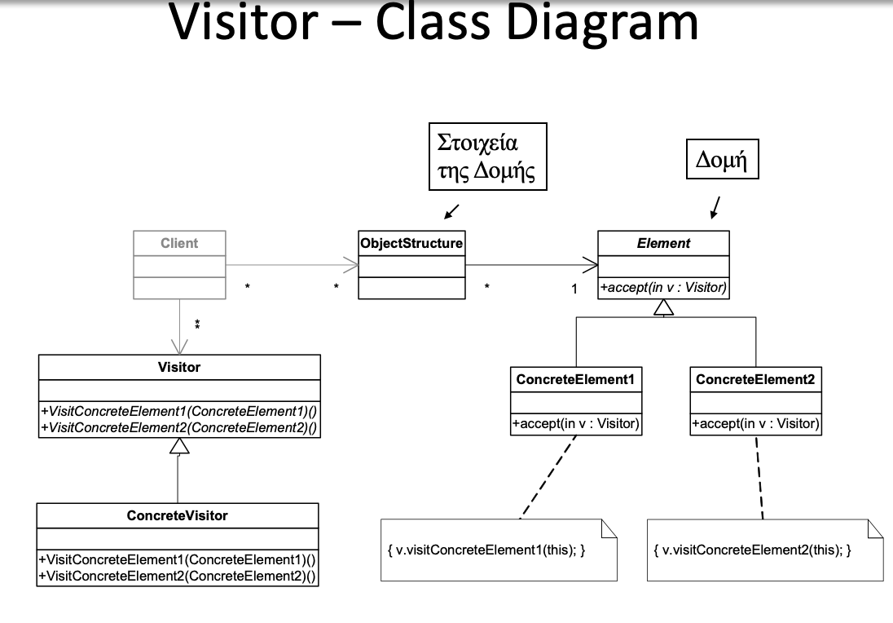

# **Iterator Design Pattern**

* Intent: access elements sequentially without exposing representation
* Used when:
  + Require multiple traversal algorithms over a structure
  + Require uniform traversal interface over different structures
  + When structure classes and traversal algorithm must vary independently
* **Strengths:** flexibility, multiple iterators = multiple traversal algorithms
* **Weaknesses:** additional communication overhead between iterator and structure
* **Example of use:** Penpoint traversal driver/slave, InterViews Listltr, Unidraw Iterator

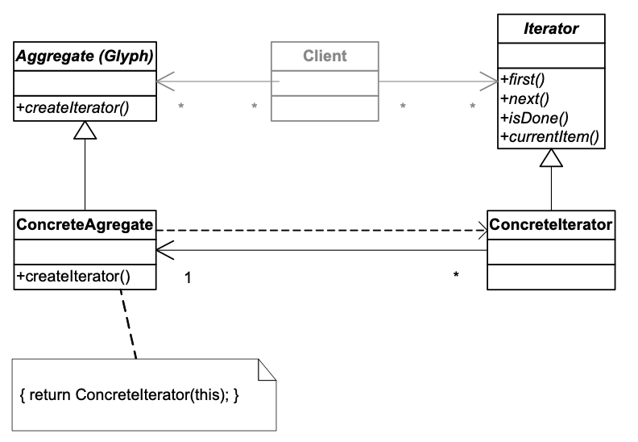

# **Observer (Behavioral)**

* **Intent**: Define a one-to-many dependency between objects
  + When one object changes state, all those dependent to it are updated automatically
* **Used when:**
  + Abstraction has 2 aspects: one dependent on the other
  + When a change to one object requires changing others, and you don’t know how many objects need to be changed
  + When an object should notify other objects without carrying about who the objects are
* **Strengths:** modularity: subject and observers can vary, extensibility: can define/add as many number of observers, customizability: different observers provide different views
* **Weaknesses:** unexpected updates: observers don’t know each other
* **Examples:** Smalltalk model-view-controller (MVC), Interviews (subject and views)

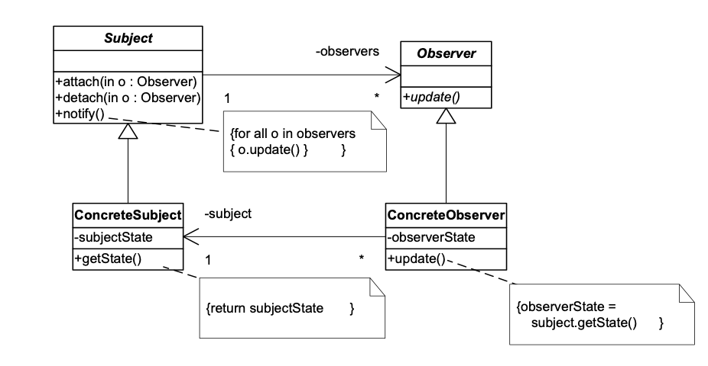

# **State Design Pattern**

* **Intent:** allow object of class to change behavior according to current state.
  + **Applied to all objects in the same state**
* **Used when:**
  + want object to denote different behaviors that objects have when they’re in different states
  + Eg. Robot move slowly when responds to the “move”. If battery is “low” then go slow, if battery is “high” then move fast.
* Classes of State Design Pattern:
  + **Context:** interface which client code accesses. Associated entity that refers to specific state. This entity is an implementation (ConcreteStateA, ConcreteStateB)
  + **State:** interface holding behavior for specific state of a context (handle).
  + **Concrete State:** subclass of State which implements the behavior that is associated with given context

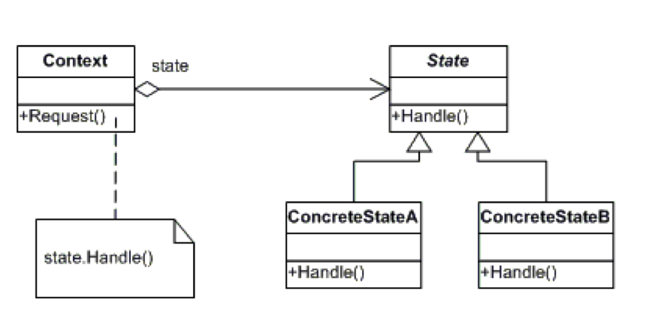

# **Strategy Design Pattern**

* **Intent:** Design family of algorithms when called, client programs/algorithms can change.
* **Used when:**
  + Object should associate with one/more algorithms to perform task
  + Algorithms can be encapsulated and common interface can be used to call all these algorithms
* **Strengths:** flexibility, code reuse, dynamically change algorithms to be called from client code
* **Weaknesses:** Cost to associate algorithms to objects, need for common interface for all algorithms used

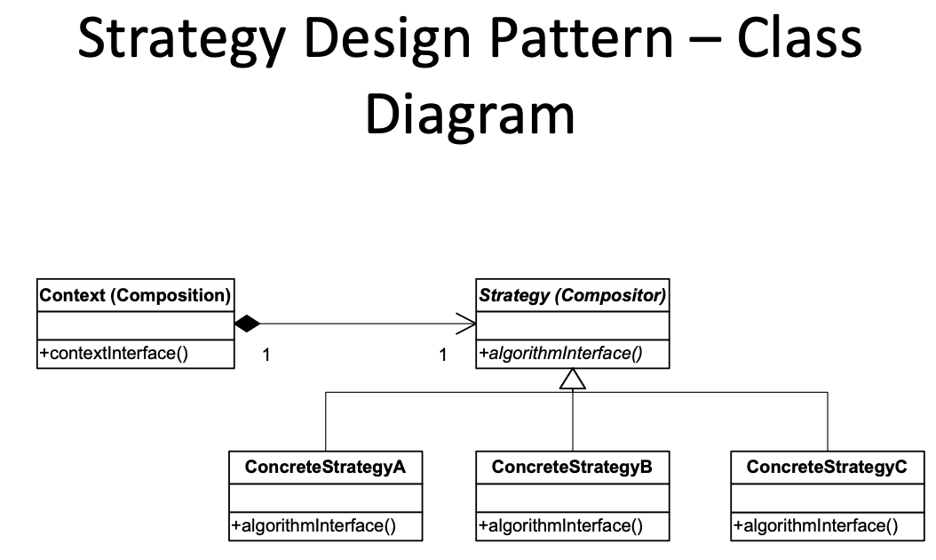

# **Template Method Design Pattern**

* **Intent:** define general structure (steps) of algorithm with ability to change logic of some steps in specific cases
* **Used when:**
  + Basic steps of algorithm can be used in class, and subclasses can implement variations of specific steps
  + Want to bring together basic steps of algorithm in class to promote reusability
* **Strengths:** code reuse and one way communication (“don’t call us we’ll call you”)
* 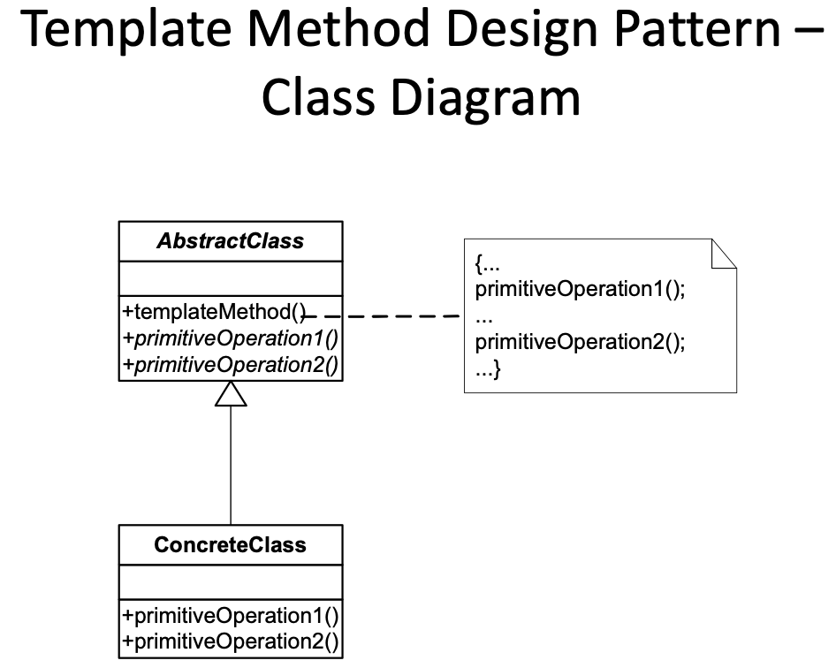**Weaknesses:** use of subclasses for specializing behavior of substeps of main algorithm

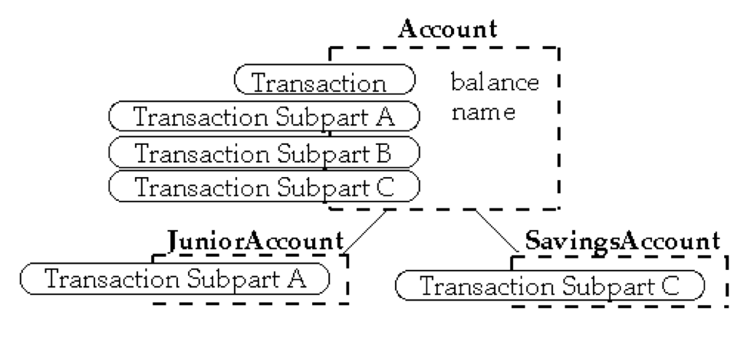

# **Change of Responsibility Design Pattern**

* **Intent:** promote low coupling (less dependency between classes) between sender of request & objects handling it. Allows one or more objects to handle request.
* **Used when:**
  + Objects that handle request are “chained” so one passes request to another
  + Result is request to be able to be managed by one or more objects

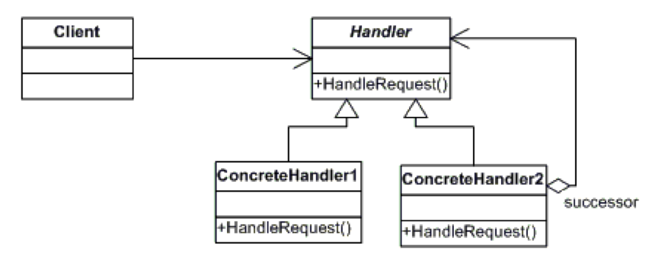



STRUCTURAL

# **Adapter Design Pattern**

* **Intent**: allow client code to access object w/ many interfaces from interface client code expects object to have, without changing neither object or client code
* **Used when**:
  + To replace class A with class B which has different interface (without changing clients using class A)
  + To implement class that interacts with other classes which we do not know yet
* **Structural Elements:** Uses classes: *Target, Adaptee, Adapter, Client*

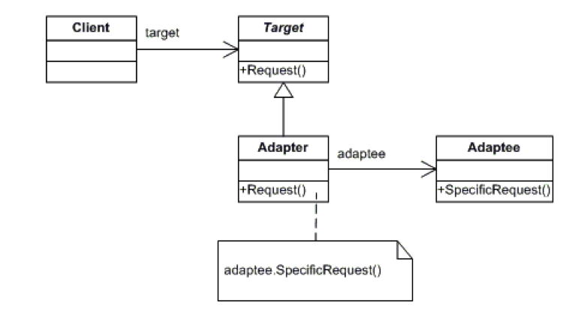

# **Bridge Design Pattern**

* **Intent**: provide alternate implementations between interface and implementation
* **Used when**:
  + Implementing layered architectures.
  + In conjunction with Abstract Factory Design Pattern where Bridge can use Abstract Factory to decide which implementation to be used for which abstraction
* **Structural Elements:** Uses classes: *Abstraction* (reference to implementation object), *RefinedAbstraction* (extend interface defined in abstraction), *Implementor* (defines interface from implementation class. Defines specific detailed operations) and *ConcreteImplementor* (implement concrete operations of class implementor)

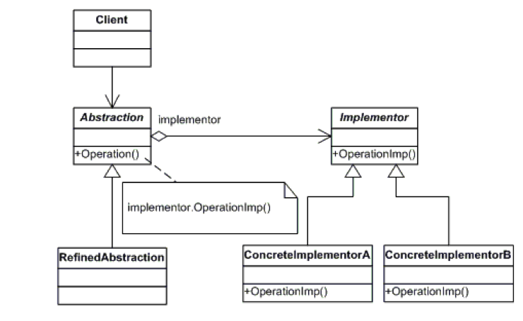

# **Composite Design Pattern**

* **Intent**: manipulate single instance of object same as you would manipulate a group of them. Compose objects into tree structures to represent whole-part hierarchies. Recursive composition.
* **Used when**:
  + Processing of a primitive object is handled one way and composite object another.
* **Structural Elements:** Uses classes: *Abstraction* (reference to implementation object), *RefinedAbstraction* (extend interface defined in abstraction), *Implementor* (defines interface from implementation class. Defines specific detailed operations) and *ConcreteImplementor* (implement concrete operations of class implementor)

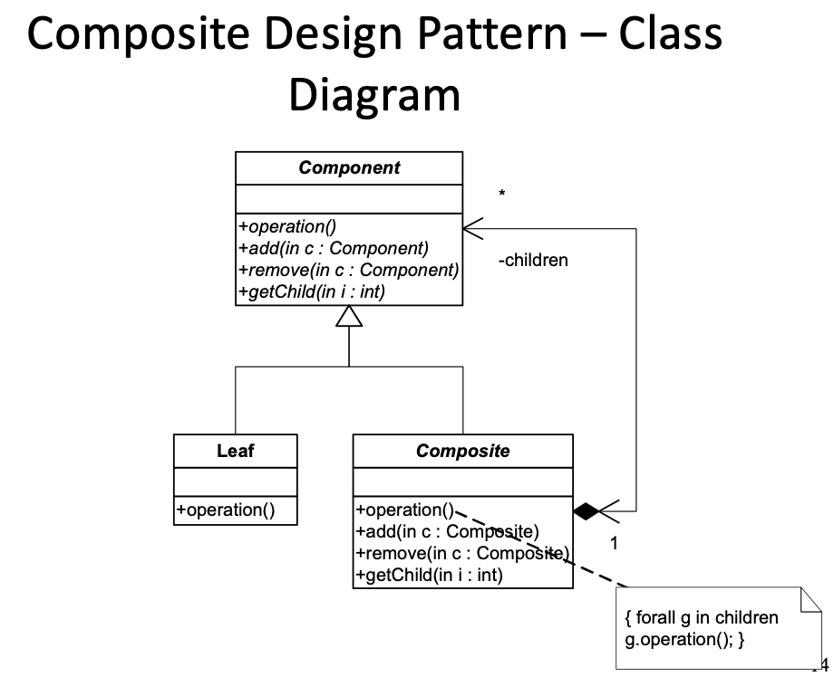

# **Facade Design Pattern**

* **Intent**: serve as the connector between the object and the entities instead of linking them directly (makes for more cleaner and organized code)
* **Used when**:
  + 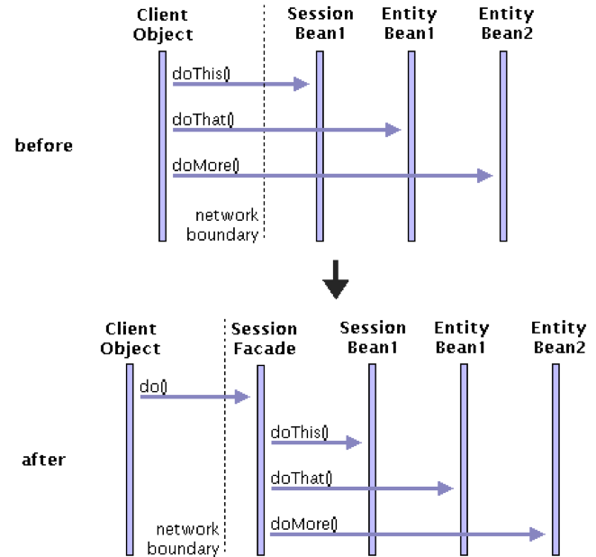Want to provide an interface to go through instead of going straight to the methods. Example (client application -> banking session façade -> customer home, customer, savings, chequings, etc.)



# **Proxy Design Pattern**

* **Intent**: create “substitute” object which holds reference for an object to control it.
* **Used when**:
  + Function takes lots of time to execute, “substitute” object can send messages about progress of function back to the client code.
  + Provide complementary functions on behalf of the object for which it acts as a substitute. IE. The “substitute” object can provide additional functions for security, access control, etc.
* **Classes:**
  + *Proxy:* reference to real object and controls access to it.
    - *Remote proxies:* receive call/encode it, then send to “real” object in another computer or space.
    - *Virtual proxies:* hold information about status of actual object to postpone access to it
    - *Protection proxies*: check if caller has correct credentials to invoke actual object and its features.
  + Subject: denotes common interface for *proxy* and *realSubject* so proxy can be used wherever realsubject is used
  + RealSubject: defines “real” object that will eventually be accessed and use services.

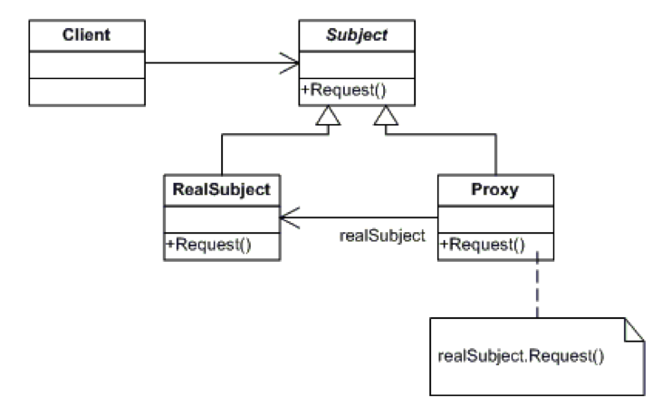

# **Decorator Pattern**

* **Intent**: Add new features to the methods of a *single* object.
* **Used when**:
  + Don’t want to extend functions of object using inheritance (sub classes)
  + Want to dynamically expand functionality of single object and remove them if wanted.
  + Increase functions of specific objects instead of all objects from class
* This pattern is also known as “Wrapper”. Structure based on use of object (Decorator) with same interfaces as object we want to expand functions of.
  + When we call Decorator method, call is forwarded to object that Decorator “wraps”
* **Recursive composition**
* “has a” up the “is a” hierarchy



* CREATIONAL

# **Singleton Design Pattern**

* **Intent**: ensure in software application we can only construct limited # objects. This class provides reference point to that unique object(s).
* **Used when**:
  + Guarantee class produces only one object no matter how many times we call constructor
  + Want to have unique/global reference point for this unique object
  + Allow object to be expanded using subclassing without changing client program
* This pattern is also known as “Wrapper”. Structure based on use of object (Decorator) with same interfaces as object we want to expand functions of.
  + When we call Decorator method, call is forwarded to object that Decorator “wraps”

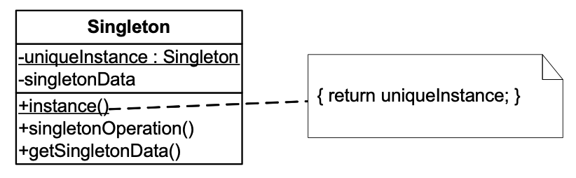



# **Factory Method Design Pattern**

* **Intent**: define interface in a class that can be used to construct objects. Their type depends on what classes are applied in the FactoryMethod interface.
* **Used when**:
  + This way, client code does not need to know in advance the names of the classes.
* **Structure:** *Product* (specify abstract class), *ConcreteProduct* (implement interface by Product), *Creator* (define FactoryMethod interface to construct and return Product item), *ConcreteCreator (*sub class of Creator to construct/return object for client code.

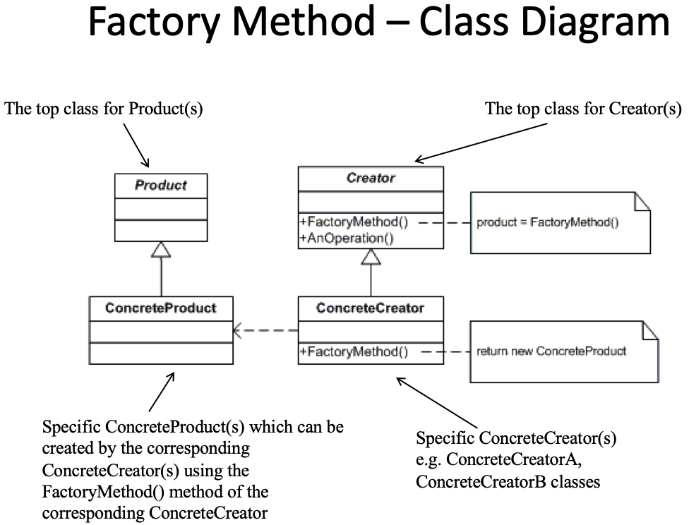

# **Abstract Factory Design Pattern**

* **Intent**: construct families of related objects without identifying names of respective classes that construct them. Use a “workshop” to construct objects – can be selected for any case or type to determine type of object constructed. Client code does not need to know details/names of these classes being constructed.
* **Used when**:
  + Do not know in client code for which classes we should build objects.
  + Hiding logic of building these objects in a “workshop”, and use this “workshop” according to conditions/requirements of application.
  + Supports “family” of products
* **Structure:** *Product* (specify abstract class), *ConcreteProduct* (implement interface by Product), *Creator* (define FactoryMethod interface to construct and return Product item), *ConcreteCreator (*sub class of Creator to construct/return object for client code.

